Histogram : Inference : Data is not normal and is positively skewed and has outliers.

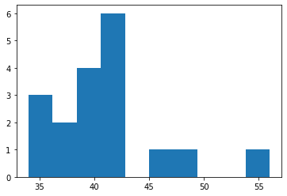

Boxplot : Inference : Data is positively skewed and outliers are seen on the upper whisker.

